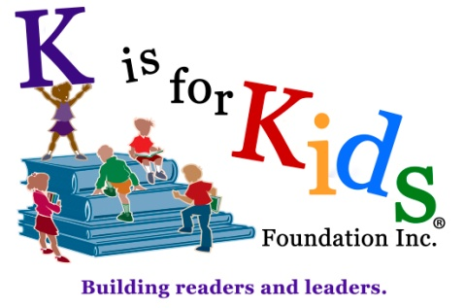

Teen Illustrator Contest - Entrant Questionnaire

Name __________________________________ Date _____________________

School Name _______________________________Grade/Year______________

Cell Phone ___________________ E-Mail ______________________________

Emergency Contact _________________________ Relationship _____________

Phone Number(s): please list _________________________________________

How did you hear about K is for Kids? ______________________________________

Would you like to boost your resume or build your portfolio? ___ Yes ___ No

Are you interested in volunteering or serving in a leadership or internship role?
___ Yes ___ No If yes, what role(s): _____________________________

Have you had previous leadership experience? ___Yes ___No

If yes, please provide your title and role: _____________________________________

If you would like to volunteer for K is for Kids, please continue to page two.
239.596.KIDS (5437) * kisforkids.org * facebook * instagram * pinterest * and more

“Building readers and leaders”

K is for Kids® is a unique teen driven volunteer-based nonprofit 501(c)(3) organization building readers and leaders with kids on both the giving and receiving ends of its mission. Student leaders serve as the foundation's young executives applying entrepreneurial principles to create and manage programs that offer kids of all ages a "ladder for leaders" as they "Climb higher. Help others." Through its focused efforts, K is for Kids cultivates the skills kids need to be creative thinkers, adventurous problem solvers and visionary leaders.

Reading and dreaming, learning and leading, creating and achieving:
05-15
That's K is for Kids!

