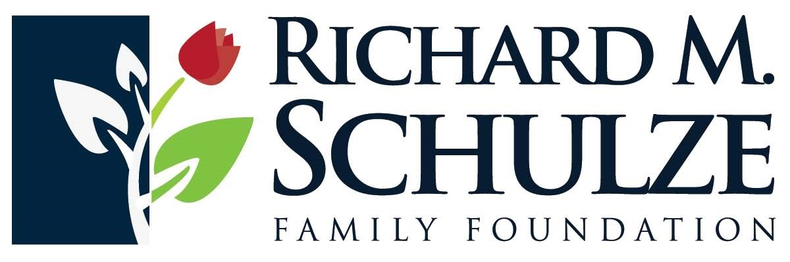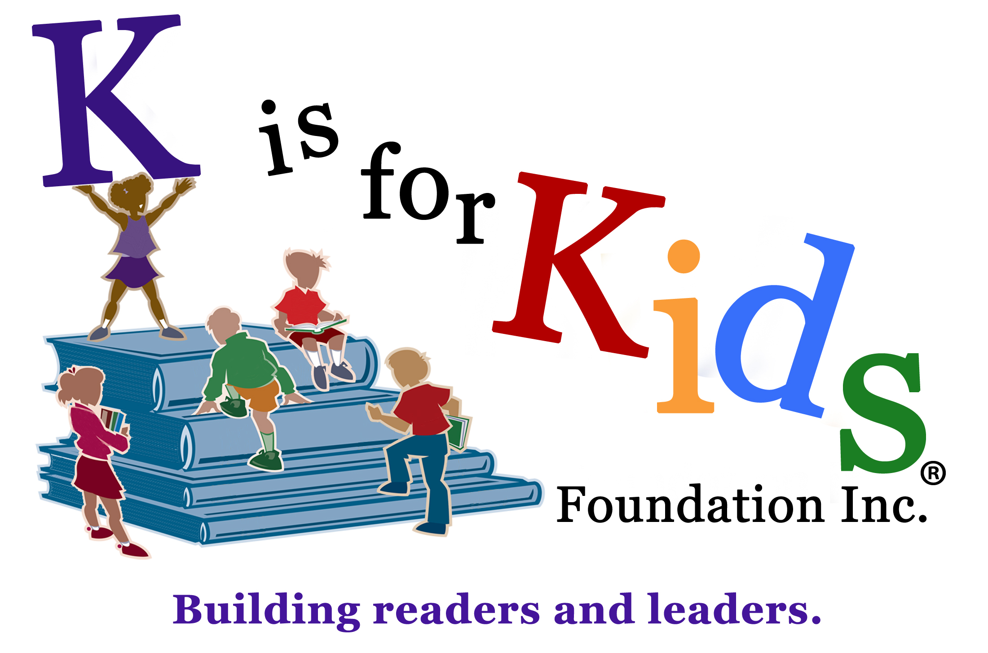
3rd Annual
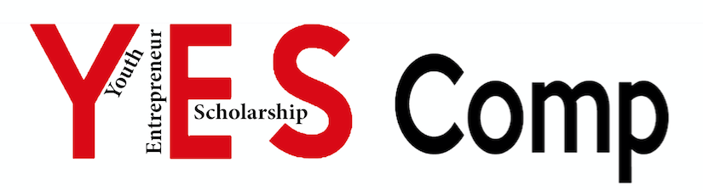
Do you dream of being an entrepreneur?

Do you want to start your own business one day?

The 3rd Annual K is for Kids YES Comp - Young Entrepreneur Scholarship Competition - is an initiative by K is for Kids Foundation to foster your innovation and community involvement.
The winner will receive a $1,000 scholarship to support their entrepreneurial passion.
Runner-up receives $500, third place, $250.

The competition is open Collier County high school junior and senior students.

Photo by Ann Alvarez, Gulf Coast High School
K is for Kids’ Young Entrepreneurs 2015, shown above: At left, Tyler Schult, a senior at Barron Collier High School and at right, Hadrien Roy, a senior at Barron Collier High School. At center is Craig Bouchard, a New York Times bestselling author, international businessman, and K is for Kids’ Shining Star Award recipient 2014.

K is for Kids’ Young Entrepreneur Scholarship Application 6
Winner receives a $1,000 scholarship * Runner-up receives scholarship of $500 * Third-place finalist receives $250
ENTRY DEADLINE WEDNESDAY, APRIL 20th
Three Semifinalists To Be Announced Friday, April 22nd * Presentations To Be Given On Saturday, April 30th
COMPLETE & EMAIL TO Karen@kisforkids.org
Student Name: _____________________________________________ D.O.B. ___________________
School: ___________________________________________ Grade: __________ GPA: ____________
Mobile phone no. ____________________ Email address _____________________________________
List or circle below the entrepreneurial skill(s) and/or traits you possess. ___________________________________________________________________________________
Examples: * Creative problem solving * Vision * Resilience * Resourcefulness * Flexibility * Tenacity * Ability to utilize existing resources * Self-confident * Strong self-belief * Passion * Trail blazer
The K is for Kids’ Young Entrepreneur Scholarship competition’s goal is to help you apply the skills you need for your business, project or idea to K is for Kids’ “business” of helping others. (See page 4.)
Business plan:
Do you have a unique idea for a business, product or service? Perhaps you have an idea of how to earn money while in high school or to help fund your post-secondary education. Consider your business idea(s), then reply to the following (any details shared will be kept confidential).
What is the purpose of your business? _____________________________________________________
- Describe your product and/or service. ______________________________________________________
- Top three goals for your business: _________________________________________________________
________________________________________________________________________________________
- Who are your target customers? ___________________________________________________________
- How you will market to them? ____________________________________________________________
- Who is your competition? _______________________________________________________________
- Why would customers buy from your company vs. your competition? ____________________________
________________________________________________________________________________________
Page 2
Young Entrepreneur Scholarship Awards will be paid directly to the first, second and third place winners to help fund their business development and/or to help pay for their post-secondary education.
Please describe how you anticipate utilizing your funding.
____________________________________________________________________________________
____________________________________________________________________________________

Student Signature___________________________________________ Date _____________________

Please print: Parent or legal guardian’s name _______________________________________________
Parent Signature ____________________________________________ Date _____________________

Representative for K is for Kids ____________________________________Title _____________
Date ______________
The Annual K is for Kids Entrepreneur Scholarship Competition is an initiative by the K is for Kids Foundation to foster students’ innovation and community involvement.
Contestants may enter individually, with a partner, or team. First place will win a scholarship of $1,000 to support their entrepreneurial passion. Second place will receive $500, and third place, $250.
2016 Contest Timeline:
- Wednesday, April 20th: Contest entry deadline
- Friday, April 22nd: Three finalists will be notified by email and phone call.
- Saturday, April 30th: Presentations to be given at Barron Collier High School in the Incubator classroom at 11:00 a.m. The Top Leaders Reception will follow with the awarding of certificates of recognition to K is for Kids Foundation’s top student leaders, interns and scholarship recipients. Following the reception, YES Comp winners will be announced and awarded their scholarship monies.
Rules
- Students must be a junior or senior in any Collier County high school
- Students must document their plan with a PowerPoint presentation & business plan
For more information, visit our website at www.kisforkids.org or text 239.595.0077

