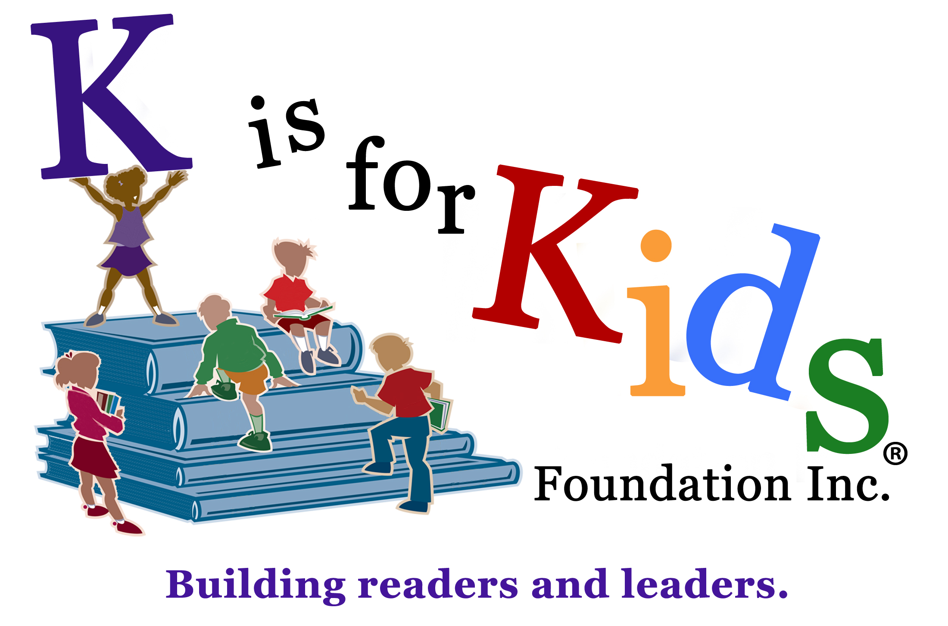
3rd Annual
Do you dream of being an entrepreneur or creating your own company?
The 4th Annual K is for Kids YES Comp - Young Entrepreneur Scholarship Competition - is an initiative by K is for Kids Foundation to foster your innovation and community involvement.
The winner will receive a $1,000 scholarship to support their entrepreneurial passion.
Runner-up receives $500, third place $250, and fourth place $100.

The competition is open Collier County high school junior and senior students.

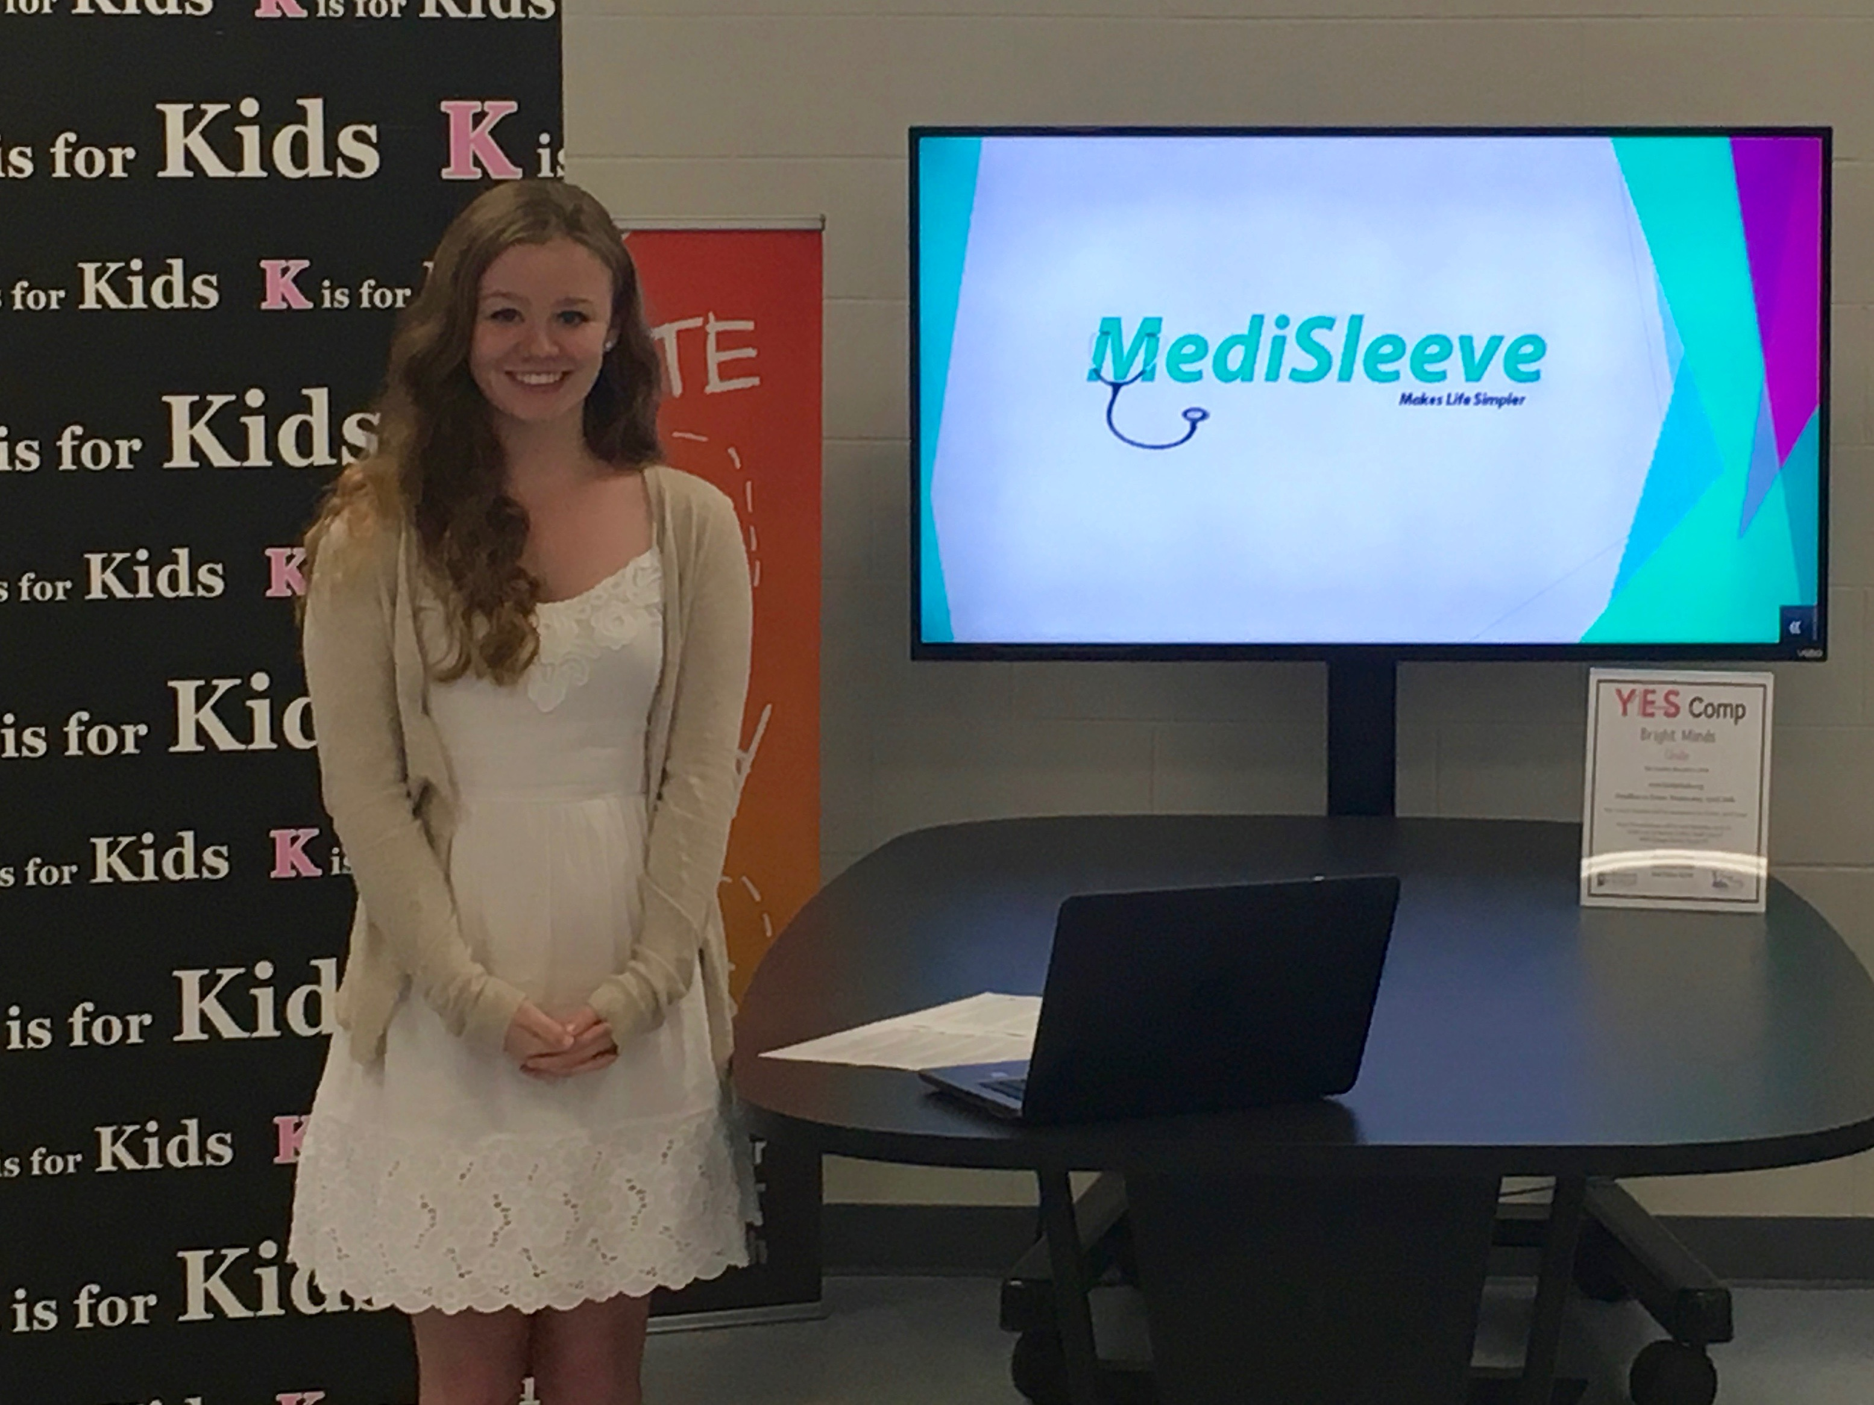
K is for Kids’ 2016 Young Entrepreneur, Gabriella Manuszak of MediSleeve. Gabriella, a senior at Barron Collier High School, is now a student at the University of Florida.

K is for Kids’ Young Entrepreneur Scholarship Application
Submit the questionnaire and your business plan by midnight, Sat., APRIL 29th
The Annual K is for Kids Entrepreneur Scholarship Competition is an initiative by the K is for Kids Foundation to foster students’ innovation and community involvement.
The competition’s goal is to help you develop and apply the skills you need to create your business, and how to pitch it to investors.
Contestants may enter individually, with a partner, or team. First place will win a scholarship of $1,000 to support their entrepreneurial passion. Second place will receive $500, third place $250 and fourth $100.
2016 Contest Timeline:
- Sat., May 29th: Contest entry deadline (by midnight)
- Sun., May 30th: Four finalists will be notified by email and phone call.
- Sat., May 6th: Presentations to be given at Barron Collier High School in the Innovation Room starting at 2:00 p.m. Winners will be announced after and scholarship monies awarded.
Rules
- Students must be a junior or senior in any Collier County high school
- Students must document their plan with a PowerPoint presentation & business plan
For more information, visit email Karen@kisforkids.org or call/text 239.595.0077

COMPLETE & EMAIL to: Karen@kisforkids.org
Individual Or Lead Student’s Name: _____________________________________________
D.O.B. ___________________ School: ___________________Grade: __________ GPA: ________
Mobile phone no. ____________________ Email address _____________________________________
List or circle below the entrepreneurial skill(s) and/or traits you possess. ___________________________________________________________________________________
Examples: * Creative problem solving * Vision * Resilience * Resourcefulness * Flexibility * Tenacity
Ability to utilize existing resources * Self-confident * Strong self-belief * Passion * Persistence * Trail blazer
Business plan: Please submit your business plan or answer the following questionnaire (use a separate piece of paper if needed).
Q U E S T I O N N A I R E
Do you have a unique idea for a business, product or service? Perhaps you have an idea of how to earn money while in high school or college. Please complete (details presented will be kept confidential).
- What is the name your business? _____________________________________________________
- Describe your product and/or service. _______________________________________________________
- Top three goals for your business: __________________________________________________________
- _______________________________________________________________________________________
- _______________________________________________________________________________________
- Who are your target customers? ___________________________________________________________
- How you will market your product/service to them? __________________________________________________________________________________________________________________________________________________________________________________________
- Who is your competition? _________________________________________________________________
- Why would customers buy from your company vs. your competition? ______________________________
______________________________________________________________________________________
Young Entrepreneur Scholarship Awards will be paid directly to the first, second, third and fourth place winners to help fund their business development and/or to help pay for their post-secondary education.
Please describe how you anticipate utilizing your scholarship monies.
____________________________________________________________________________________
Student Name (print) _____________________________ Signature ____________________________ Date _________
(If under 18) Parent or legal guardian’s name (print) __________________________________________
Parent Signature ____________________________________________ Date _____________________
Student Name (print) _____________________________ Signature ____________________________ Date _________
(If under 18) Parent or legal guardian’s name (print) __________________________________________
Parent Signature ____________________________________________ Date _____________________
Student Name (print) _____________________________ Signature ____________________________ Date _________
(If under 18) Parent or legal guardian’s name (print) __________________________________________
Parent Signature ____________________________________________ Date _____________________
Student Name (print) _____________________________ Signature ____________________________ Date _________
(If under 18) Parent or legal guardian’s name (print) __________________________________________
Parent Signature ____________________________________________ Date _____________________

